# Badrang Beats

COMP 360: Intro to Artificial Intelligence

Section: B

Submitted by:

Umm-e-Abiha 231522019

Faizan Ahmed Qadri 241608482

Laiba Hassan 2415530666

Submitted to:

Dr. Aasia Khanum

Table of Contents

Badrang Beats 1

Introduction 3

Abstract 4

Literature Review 6

Methodology 8

Experiments and Results 9

Conclusion 10

References 11

# Introduction

In recent years, streaming services with huge libraries of music and movies have completely changed the entertainment business. With so much media out there, it can hard to find new songs or movies that we like. The job of badrangbeats come into play here.

The platform uses AI and machine learning to give each user new and interesting content. Making it easier for them to find and enjoy interesting content. The project brings together music, film and technology to create a one-of-a-kind place for people who like to be entertained.

It will going to use Machine Learning Algorithms to look at how (Sotiropoulos & Tshihrintzis 2018) a song or movie sounds and look to figure out what genre and subgenre it belongs to. The systems looks at what the user likes to watch and listen to and then makes recommendations based on that information.

# Abstract

The Bandrangbeats project is an innovative endeavor that aims to revolutionise the entertainment business through the utilization of artificial intelligence and machine learning. With the proliferation of streaming services that provide users with access to enormous libraries of music and films, the issue now is to assist consumers in finding fresh and fascinating content that is tailored to their individual tastes. Bandrangbeats is able to overcome this obstacle by delivering individualised recommendations that are based on user preferences.

Bandrangbeats provides its users with the opportunity to have a one-of-a-kind viewing and listening experience by classifying music, movies, and artists into separate categories using cutting-edge artificial intelligence (AI) and machine learning (ML) algorithms. The classification of songs and films into their respective genres and subgenres is determined by the system through an analysis of the aural and visual characteristics of each, which in turn ensures correct and pertinent suggestions.

Users of the site are given the ability to investigate a wide variety of different forms of entertainment, which makes it much simpler for them to locate and appreciate content that is relevant to their interests. Bandrangbeats delivers a one-of-a-kind destination for entertainment aficionados by integrating the worlds of music, movies, and technology. This results in an experience that is both seamless and immersive.

Bandrangbeats has the potential to revolutionise the way in which people find and interact with different forms of entertainment. The initiative introduces users to new and intriguing content, hence revolutionising the traditional techniques of content consumption. It does this by providing users with personalised suggestions and by utilising the power of artificial intelligence. The integration of artificial intelligence, machine learning, music, and films opens up new possibilities for the entertainment sector. This results in increased customer pleasure and the creation of a distinctive platform for the sharing and linking of interests.

In conclusion, Bandrangbeats is an exciting and forward-thinking initiative that fuses the depth of music and film with the most cutting-edge technologies. It aspires to change the entertainment landscape by giving users with personalised suggestions, with the intention of bringing them a selection of content that is both fascinating and diversified. Bandrangbeats is poised to make a huge impact on the industry as a result of its potential to transform the ways in which individuals locate and interact with the forms of entertainment that they enjoy the most.

# Literature Review

This literature review explores previous research on building recommendation systems, particularly in the domain of music, which is relevant to the Badrang Beats project. The review highlights key studies that have focused on recommending music based on user preferences and behaviors.

One notable study by Eyjolfsdottir et al. emphasizes the challenge of finding suitable music in today's vast digital landscape. They propose a movie recommendation system that utilizes machine learning and K-means cluster analysis. Although their research focuses on movies, the underlying principles can be applied to music as well. By creating a user model using SVM-based learning techniques, the system predicts genres and periods preferred by users based on personal information. While their implementation in Java achieved success with a limited dataset, a larger dataset with more features could yield even more reliable music recommendations.

In a research effort by Subhankar Joardar et al., various effective movie recommendation systems were introduced. Collaborative filtering models, cosine similarity, linear SVM methods, and genetic algorithms were employed. The genetic algorithm approach, while offering improved solutions over time, was computationally expensive. However, the study achieved a high level of accuracy close to 80% after multiple iterations, which suggests the potential effectiveness of similar approaches for music recommendation.

Lund & Ng proposed a deep learning approach based on autoencoders for collaborative filtering in movie recommendation systems. Their research explored the use of deep learning to predict users' ratings on new movies, resulting in improved recommendations compared to traditional techniques such as k-nearest neighbors and matrix-factorization. Users' ratings and a survey indicated that the deep learning approach was preferred by a significant majority (71.67%) of respondents. The study demonstrates the potential of deep learning techniques for music recommendation, as it relies on similar principles.

Additionally, Kaushik et al. developed a collaborative filtering-based recommendation system that learned latent features from user ratings and item similarities. Their system calculated similarities using the cosine similarity formula and utilized VGG16 in Keras to train neural networks. Although no specific evaluation metric was defined, A/B testing suggested that their model, which incorporated deep learning and visual aspects of movie posters, produced high-quality recommendations.

These literature reviews collectively highlight the importance of considering user preferences, machine learning algorithms, and deep learning techniques in building effective recommendation systems. While the studies primarily focused on movies, the underlying principles can be applied to the Badrang Beats music project. By leveraging these insights, the Badrang Beats project can draw inspiration from successful approaches in the movie domain and adapt them to create an innovative and personalized music recommendation system.

# Methodology

Our music recommendation system has been compiled using a hybrid recommending system that comprises of both content-based and collaborative filtering techniques, along with the cosine similarity method. We used the libraries such as numpy, pandas diflib and mathlib.

I. Using Hybrid Recommendation System:

Our hybrid system combines content-based filtering and collaborative filtering techniques to provide an efficient music recommendation system. We utilized a dataset specifically focused on music, which contains information about songs, artist’s name, track’s name, release’s date, genre, lyrics, length, dating, violence, world/life, night/time, shake the audience, family/gospel, romantic, communication, obscene, music, movement/places, light/visual perceptions, family/spiritual, like/girls, sadness, feelings, danceability, loudness, causticness, instrument, valence, energy, topic, age. Python libraries were used for data analysis of the music dataset.

# a) Content-Based Filtering:

Content-based filtering (CBF) uses the information about the artist's name, type and other attributes of the songs that has been previously listened and rated by the user, to imitate the listeners music choices. the algorithm suggests the music just like the ones that are liked or listened mostly by the user. By comparing multiple songs with the ones previously rated by the user, the system identifies the best-matching songs to recommend. The core element in content-based filtering is that it relies on the data of only one user to make predictions. Using this method, we calculated a user's preference vector based on the genres of the songs they liked.

Collaborative filtering:

Collaborative filtering algorithm focuses on different users' ratings of songs to recommend music to an active user. It filters out songs according to the interests and preferences of users who have similar tastes to the active user. The underlying assumption of collaborative filtering is that if person A has the same opinion as person B on a set of songs, A is more likely to have B's opinion for a given song than that of a randomly chosen person.

To measure the similarity between users and the active user, we used the Pearson Correlation Function, which measures how much users are correlated with each other. Based on the input of songs provided by the active user, we created a subset of users who have listened to and rated the same songs. Pearson Correlation between the active user and every user in the subset group was then calculated using the formula:

Pearson Correlation(r) = (Σ((xi-x̄)(yi-ȳ))) / (sqrt(Σ(xi-x̄)²) * sqrt(Σ(yi-ȳ)²))

This calculation gives us the similarity between the users from the subset group and the active user. A Pearson Correlation value of 1 indicates that a particular user and the active user have similar music preferences, while a value of -1 indicates dissimilarity between the two users. Hence, we select the top N users with the highest similarity (value of 1). For these N users, weighted ratings are computed by multiplying the similarity index with the respective rating. The total sum of the similarity index and weighted rating is then used to calculate the recommendation score, based on which the system recommends songs to the user.

In summary, our hybrid music recommendation system combines content-based filtering, collaborative filtering, and cosine similarity techniques. By leveraging the user's past listening preferences and similarities with other users, the system provides personalized music recommendations. The implementation utilizes libraries such as pandas, matplotlib, and numpy to analyze the music dataset and generate recommendations.

B. Cosine similarity

Cosine similarity is a measure of similarity between two non-zero vectors. It calculates the angle between the two vectors to determine their similarity. The similarity is determined by how close the angle is between the vectors. It is computed by taking the dot product of the two vectors and dividing it by the product of their magnitudes. The formula for cosine similarity is as follows:

Cosine Similarity = (A · B) / (||A|| * ||B||)

In the context of music recommendation, cosine similarity can be used to measure the similarity between different music attributes or features. For example, consider three music vectors: A, B, and C, where these vectors represent different music attributes such as genre, tempo, and mood.

The cosine similarity between A and A is 1, indicating that they are 100% similar or identical. When the cosine similarity between A and B is 0.98, it means they are 98% similar, implying a high degree of similarity between the two vectors.

In this study, a music dataset was obtained from Kaggle, which consisted of a data frame with various attributes attached to each song. For our project, we selected attributes such as genre, artist, tempo, and mood as feature elements. These feature elements were combined into a single variable that encompassed all the relevant features. Since machines cannot comprehend textual data directly, we converted these key features into feature vectors.

In machine learning, a feature vector is an n-dimensional vector of numerical features that represents an object. In the case of music recommendation, feature vectors are created to apply cosine similarity. Each attribute of a song is transformed into a numerical representation, enabling the calculation of cosine similarity between different music items.

Once the cosine similarity is calculated for a number of songs in our dataset, we can identify the most similar music item to the input song provided by the user. By comparing the cosine similarity values, we can recommend songs that share similar attributes or characteristics with the user's input, enhancing the personalized music recommendation system.

# Experiments and Results

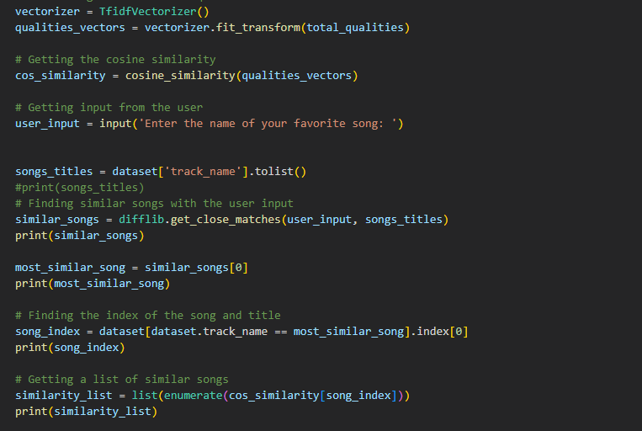

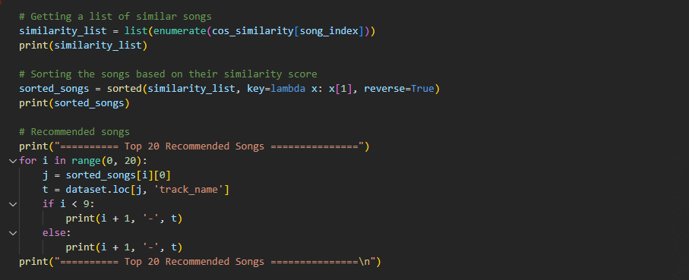

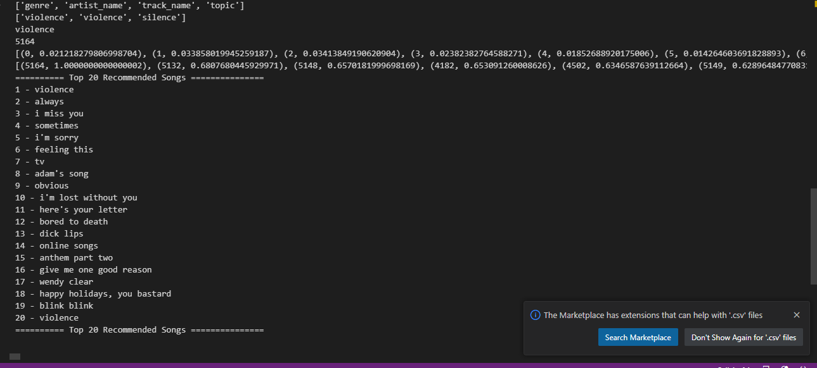

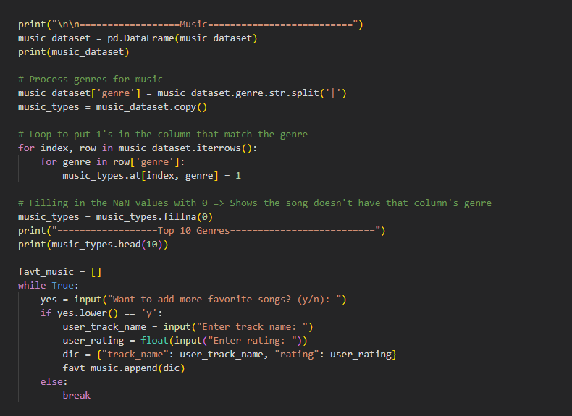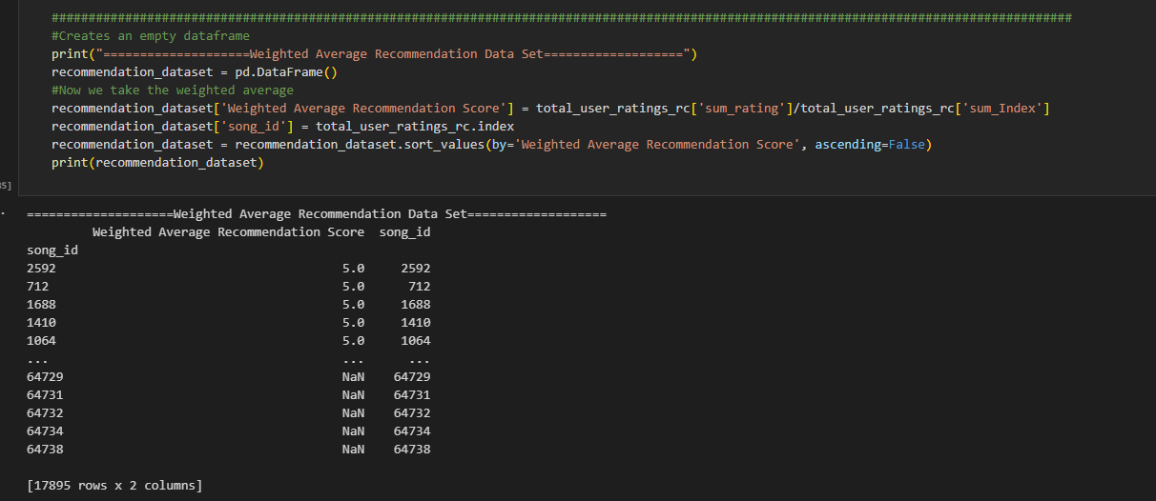

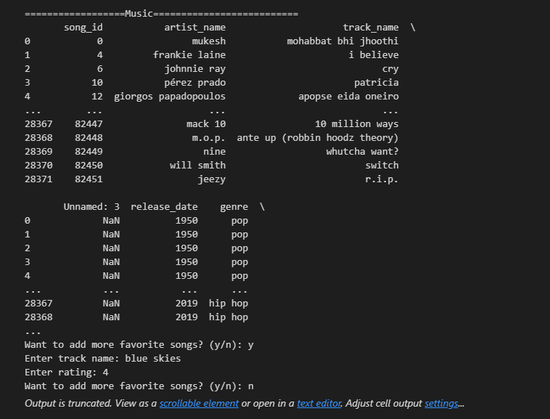

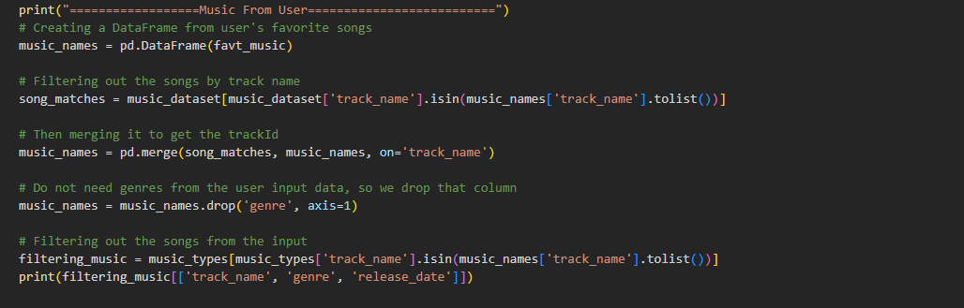

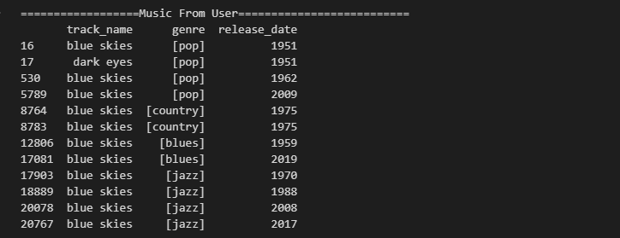

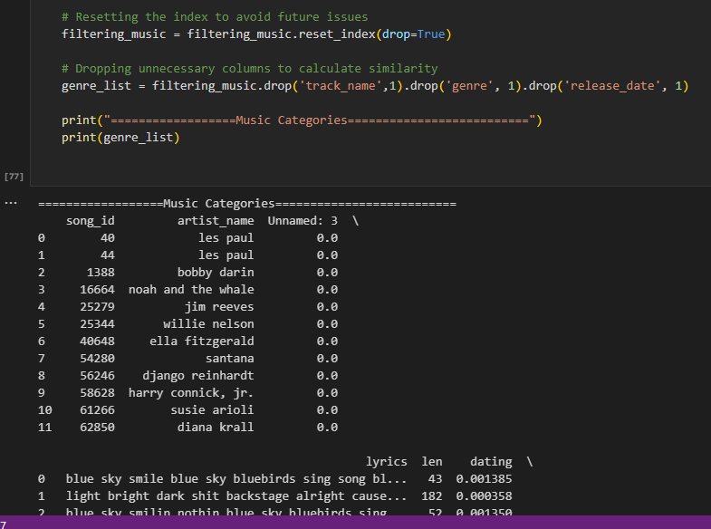

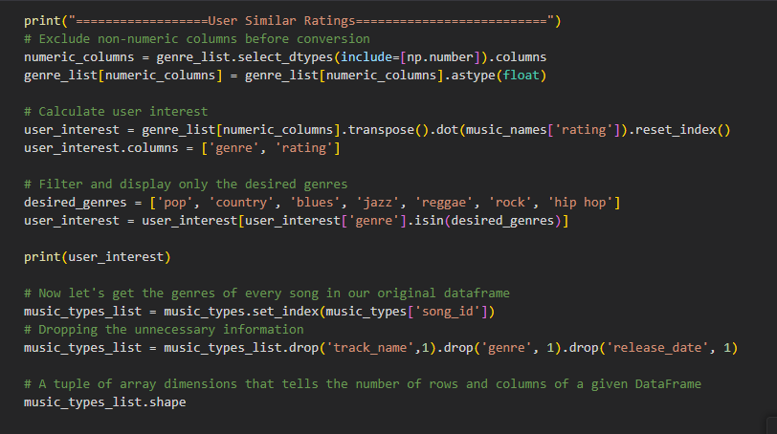

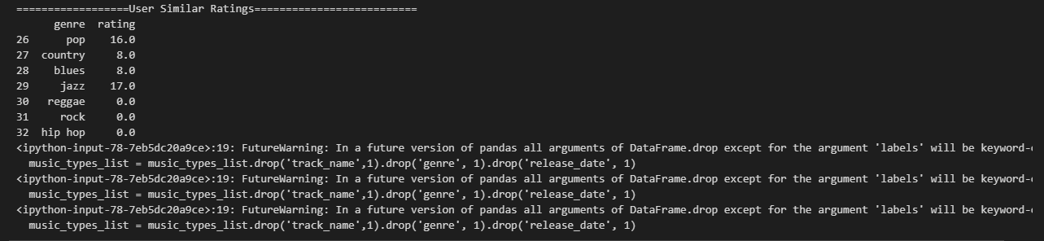

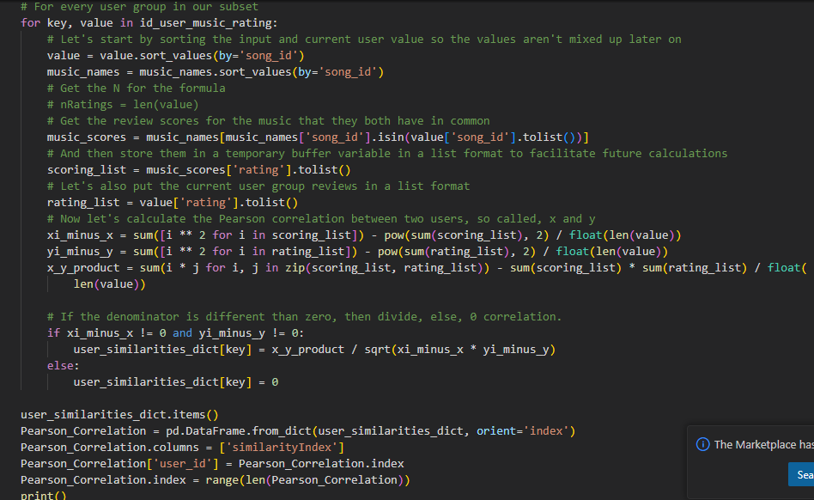

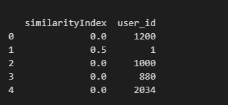

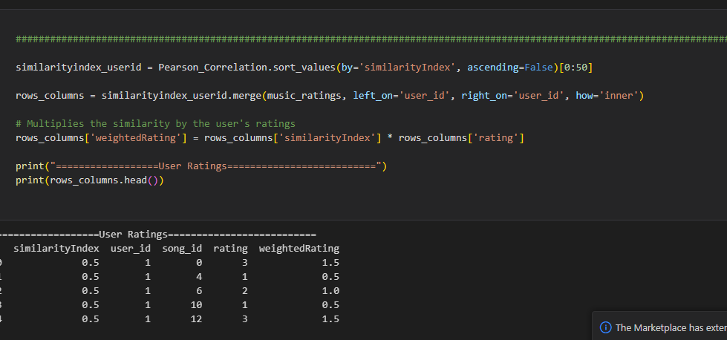

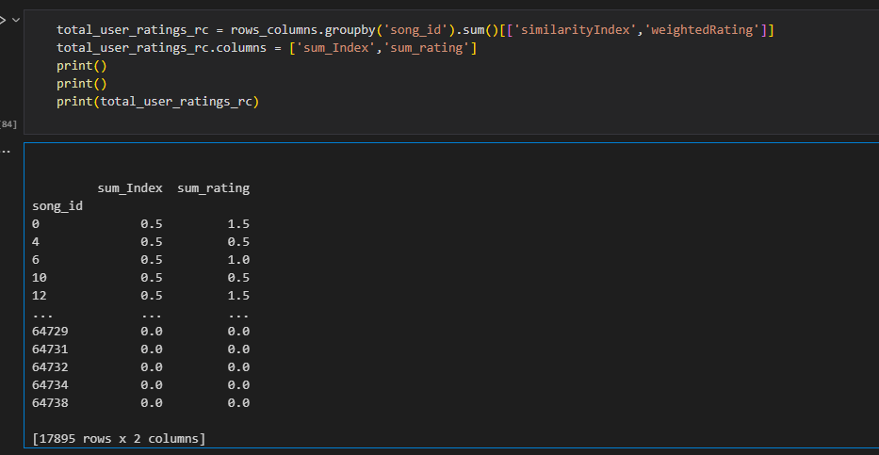

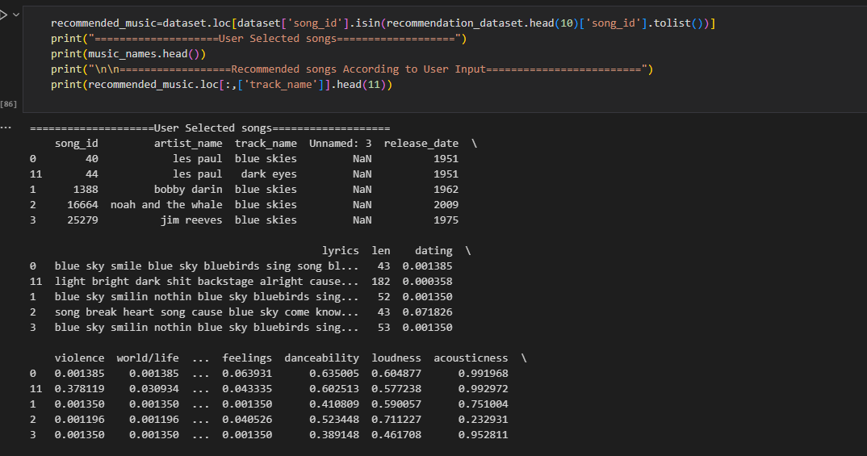

# Conclusion

The Bandrangbeats project is poised to revolutionize the entertainment industry by harnessing the power of AI and machine learning to provide users with personalized recommendations and a unique viewing and listening experience. In a time when streaming services offer vast libraries of music and movies, the challenge lies in helping individuals discover content that resonates with their preferences. Bandrangbeats addresses this challenge by employing advanced algorithms to categorize music, movies, and artists into distinct groups.

By analyzing the sonic and visual attributes of songs and movies, Bandrangbeats accurately determines genre and subgenre classifications. This enables the platform to make tailored recommendations based on each user's preferences and interests. By combining artificial intelligence, machine learning, music, and movies, Bandrangbeats creates a one-of-a-kind platform for entertainment enthusiasts.

The project's significance lies in its ability to transform the way people discover and engage with entertainment content. By offering personalized suggestions and facilitating the exploration of new and interesting music and movies, Bandrangbeats enhances the traditional methods of content consumption. It empowers users to easily find and enjoy content that aligns with their tastes, ultimately enhancing their entertainment experience.

Bandrangbeats has the potential to reshape the entertainment industry by bridging the gap between users and relevant content. By leveraging the capabilities of AI and machine learning, the project introduces a new era of personalized entertainment, creating a platform that caters to the individual preferences of users.

In conclusion, the Bandrangbeats project represents an innovative and transformative approach to entertainment. By providing personalized recommendations, it aims to redefine how individuals discover and engage with music and movies. With its integration of cutting-edge technologies and a focus on user satisfaction, Bandrangbeats paves the way for a more immersive and personalized entertainment experience.

# References

Cheng, Z., Shen, J., Zhu, L., Kankanhalli, M. S., & Nie, L. (2017). *Exploiting Music Play Sequence for Music Recommendation*. Retrieved 4 17, 2023, from https://ijcai.org/proceedings/2017/511

P.Wakure, G., & Kadrolli, V. (2013). Music Recommendation System Using Genetic Algorithm. *International journal of engineering research and technology, 2*(9). Retrieved 4 17, 2023, from https://ijert.org/research/music-recommendation-system-using-genetic-algorithm-ijertv2is90301.pdf

Rosa, R. L., Rodriguez, D. Z., & Bressan, G. (2015). Music recommendation system based on user's sentiments extracted from social networks. *IEEE Transactions on Consumer Electronics, 61*(3), 359-367. Retrieved 4 17, 2023, from https://ieeexplore.ieee.org/document/7298296

Schedl, M., Hauger, D., Farrahi, K., & Tkalcic, M. (2015). *On the Influence of User Characteristics on Music Recommendation Algorithms*. Retrieved 4 17, 2023, from https://link.springer.com/chapter/10.1007/978-3-319-16354-3_37

Sotiropoulos, D. N., & Tsihrintzis, G. A. (2018). Artificial immune system-based music recommendation. *Intelligent Decision Technologies, 12*(2), 213-229. Retrieved 4 17, 2023, from https://content.iospress.com/articles/intelligent-decision-technologies/idt328